HOTEL MANAGEMENT

TRAINING PROJECT REPORT

SUBMITTED IN THE PARTIAL FULFILLMENT OF THE COURSE CURRICULUM OF

BECHELOR OF TECHNOLOGY
(COMPUTER SCIENCE & ENGINEERING)

SUBMITTED BY

YEAR: 2013

ACKNOWLEDGEMENT

Apart from my efforts, the success of any project depends largely on the encouragement and guidelines of many others. I take this opportunity to express my gratitude to the people who have been instrumental in the successful completion of this project.

I would like to show my greatest appreciation to Mr. , external supervisor at SLR Infotech and the entire faculty of the department of Computer Science and Information Technology at (college name)from where we have learnt the basics of Computer Science and whose informal discussions and able guidance became light for us in the entire duration of this work.

I can‘t say thank you enough for their tremendous support and help. I feel motivated and
Encouraged every time I work on this project meeting. Without their encouragement and
Guidance this project would not have materialized.

The guidance and support received from the members who contributed and who are contributing to this project are vital for the success of the project.I am grateful for their constant support and efforts.

(roll no)

DECLARATION

I hereby declare that the project work entitled “ HOTEL MANAGEMENT” is an authentic record of my own work carried out at SLR Infotech Pvt Limited under the guidance of the entire faculty of the department of Computer Science and Information Technology at (college name) and Mr.(trainer name) who has contributed and supported me for the project this project work is submitted in the partial fulfillment of the requirements for the award of the degree of BECHELOR OF TECHNOLOGY ( COMPUTER SCIENCE & ENGINEERING)

(Signature of student)
Name of Student :
Roll no:
Date: ___________________

Certified that the above statement made by the student is correct to the best of our knowledge and belief.

Mr. Mr. -
(H.O.D,) (Training Head,institute)

STUDENT PROFILE

Name of Student :
University Roll No. :
Course : B.TECH
Batch : 2011-15
Company Name :
Contact No. :
E-Mail Id. :
Fathers’ Name :
Name Of Project Guide :
Designation of Project Guide : TRAINING HEAD
Contact No. Of Project Guide :
E-Mail Id Of Project Guide :
Date Of Submission :

COMPANY PROFILE

SLR InfoTech Pvt. Ltd. having development office in INDIA and Office in California USA, is one of the leading Software Development company with extensive experience in designing and development cutting edge software solutions. We are a group of highly motivated IT professionals with an ability to innovate a strong desire to excel.

SLR InfoTech is a customer focused company working to provide software solutions, which are delivered with Reliability, Timeliness, Flexibility and low cost customer satisfaction as the primary aim. The designing solutions are purely based on business and technical requirements of the project in hand. Software Development Life Cycle is strictly followed to ensure the timely delivery of the project without compromising on quality.

SLR InfoTech provides a broad range of offshore outsourcing services including Application and Systems Level Programming on Leading Technologies. It also provides wide range of Networking Solutions for Corporates, Industries and Software Development Firms.
SLR InfoTech has a niche in providing training to Engineering and MCA Students. Thousands of Engineering students from Chandigarh, Punjab, Haryana, Rajasthan and Himachal have successfully completed their Industrial and Summer Training. The focus of the Industrial Training is to facilitate students with Live Projects on latest technologies like VB.NET, ASP.NET, ORACLE DBA/DEVELOPER, J2EE, JDO, STRUTS, LINUX, Networking under the strict guidance of Industry Experts.SLR InfoTech has a high-end dedicated Software development design center with a versatile skill pool specializing in technologies like .NET, J2EE, PHP, Ajax Development and is fully equipped to expand for various projects as per the client's requirements.

Keeping just the right balance of the client's industrial experience and our tech minds, our projects transform into long-term partnerships from day one.

1.1) Products and Services offered

1) OEM Hardware
2) Programming for Mobiles
3) Software Development
4) Network Consultancy
5) Open Source Software Development
6) Project Implementation
7) Software Engineering Methodologies
8) Business Software Applications
9) Dedicated Offshore Technology Center
10) Embedded Systems

Training Programs

SLR InfoTech Pvt. Ltd. provides the corporate clients with unique strategic content, industry focus, and the opportunity to network with other key industry technologies. Their training programme has proven to be very effective in addressing our client’s business challenges
.
Project Area

SLR Infotech Pvt. Ltd subject their students to Real Time Projects catering to current
applications in the IT Industry. The students get hands-on experience on IT projects and are prepared to kick start their career with tremendous confidence. The core project areas at SLR InfoTech include: Enterprise Resource Planning (ERP), Web Based Applications, Server Based Applications, Embedded Application, New Age Web Based Solutions, Mobile Gaming Application, Management Information System, Banking, Securities & Asset Managements, Network Monitoring, Bank Loan System.

SLR InfoTech has a high-end dedicated software development design center with a versatile skill pool specializing in technologies like .NET, J2EE, PHP, ORACLE, AJAX development and is fully equipped to expand for various projects as per the client's requirement.

1.2) Setup and Goal of the Organization

SLR InfoTech is a leading technology company with the global outreach specializing in
providing top solutions for all category users. Their strong commitment towards quality has secured us a privileged position in a fast evolving market, the key advantage being a state of art of product based on cutting edge technologies.

Goal
The goal of SLR InfoTech is to be responsive to its users and provide them with software
solution to assist them in being more efficient and productive in the work
The company plans on continually improving software to help its clients take advantage new technology.

The company
Founded in 1999, SLR InfoTech is headquartered in Chandigarh, India. The activity is focused on the following major activity axes:
• Software Development
• Networking consultancy
• Project Management

The People
The people are their key strength. They pick and nurture the best to create an awesome base of expertise and talent. They are a team of young professionals, enthusiastic and talented people.

The Capabilities
The reliability of the products, the flexible licensing program and the low prices show their commitment towards their clients. SLR software strategic partnership with
reputable companies all over the world has created a global network with excellent results and outstanding performance in the distribution of software products.

1.3) Project Based Industrial Training Programs

SLR Infotech Training Division offers specialized Industrial Training Program which maps according to the current industry requirements. The focus of the Industrial Training is to facilitate students with Live Projects on latest technologies like VB.NET, ASP.NET, ORACLE ,DBA/DEVELOPER, J2EE, JDO, STRUTS, LINUX, Web Designing and Development, Networking under the strict guidance of Industry Experts.
SLR's Training Division has a successful track record and experience in training more than 60000 engineering / MCA's students for the past 12 years.
SLR Infotech training division has state-of-art campus spread over 8000 sq.ft. in the heart of Chandigarh. It has a world class infrastructure having latest machines, high-end Routers and Switches, Licensed Software, Multimedia Projectors for training etc.

1.4) Why Industrial Training From SLR?

- Specialist in 6 weeks/6 months Industrial Training for Engineers/MCA Students

- Authorised Training Partner of ORACLE, MICROSOFT, RED HAT & SUN
MICROSYSTEMS

- SLR's Industrial training programs are designed according to the industry needs

- Original Certificate & Courseware directly from parent companies like SUN Microsystems,Microsoft, Oracle, Red Hat etc.

- More than 50 Qualified & Certified Trainers with experience in Software Development

- Every students is provided with Live Projects mentored by Software Development Experts from the industry

- Guest Lecturers by Industry Experts

- Industrial Training Certificate from Software Development Company

- World Class Infrastructure with Licensed Software’s

- Classroom Training includes Audio-Visual aid, Wi-Fi Labs
- Seminars on Advanced Technologies for Oracle, Sun Microsystems & Microsoft etc.
- Air Conditioned Labs having high standard of hygiene

- Dedicated Placement Cell with 100% placement assistance

- Interview Preparation and Personality Development Programs

1.5)Technical Staff

We have a team of qualified and certified trainers who have complete understanding of the IT industry and its prospects and are geared with competence enough to train you to perfection
. They are Industry Experts who have gone through meticulous trainings, essential Vendor Certifications like Oracle, Microsoft, CISCO, Red Hat etc, having invaluable industry exposure.They persistantly bring their comprehensive real world skills and experiences to the classroom.
They also have a keen enthusiasm to keep themselves constantly updated with the latest concepts and advanced training methodologies worldwide.

1.6) Placement

SLR Infotech Pvt. Ltd provides 100% Job Assistance and expert Pre-Placement advice up till you are secured in any worthy company.
They have long acclaimed the fact that education is not solely about acuiring technical skills but also the acquisition of a persona that helps students further their academic learning into their jobs/careers thereby making them more employable.
In view of that, they chart the viable career avenues for students, empower them on their
technical skills and personalities and eventually present them to the prospective employers.
SLR Infotech Pvt. Ltd make your career plans, advise you on your competence regards the latest technology and assist in your on the whole development to finally accomplish your dream venture.SLR students have been successfully placed in:
Oracle, HCL, Dell, CISCO, Datacraft, Infosys, Airtel, Connect, Reliance, Perrot System,
Accenture, Satyam, Tech Mahindra, Second Foundation, WIPRO etc.
1.7) Placement Cell
SLR Infotech Pvt. Ltd consists of a pro-active Placement Cell which constantly upgrades is knowledge base on IT Industries and is effectively equipped to steer the students through the preplacement barriers until they are perfectly settled with some reputable job.
This Placement Club provides the latest placement scenario updates concerning the entire IT sector to the SLRites.
This Placement team constantly interacts with the industry professionals for campus interviews.
They provide you with the latest information:-
- Trends & Diamonds in the IT Sector
- Job Openings in various companies
- Expert help in CV/Resume drafting
ABSTRACT

The objective of the project is to design Hotel Management application which
enables the manager to keep the record of the hotel and the customers.

The project has been designed in C#.NET technology and consists of a SQL server which acts as the database for the project.

My motivation for the project came from my enthusiasm and strong urge to learn C# and
.NET which is one of the fastest growing technologies in today’s world.
The Hotel Management System project mainly consists of two types of users. The customers who access the information provided by the website and the administrator who modifies and updates the information.

All the data needed for the application is stored in the form of tables in the SQL server 2000.

The report contains the details of all the tasks carried out during the entire software
development life cycle of the Hotel Management Project. This document depicts all the details of the project .

Table of Contents

Acknowledgements....................................................................................................................... 2
Declaration..................................................................................................................................... 3
Student Profile..................................................................................................................................4
Company profile.......................................................................................................................... 5-9
Abstract...........................................................................................................................................10

CHAPTER 1 - VISION DOCUMENT..................................................................................... 14
1. INTRODUCTION................................................................................................................ 14
1.1 PURPOSE AND MOTIVATION....................................................................................... 14
1.2 PROJECT OVERVIEW..................................................................................................... 14
2. OVERALL PRODUCT DESCRIPTION.............................................................................. 14
2.1 PRODUCT PERSPECTIVE............................................................................................... 14
2.2 PRODUCT FEATURES................................................................................................... .. 14
2.2.1 Customer / End user activities......................................................................................... 14
2.2.2 Administrator Activities.................................................................................................... 15
2.3 USER CHARACTERISTICS............................................................................................. 15
2.4 CONSTRAINTS................................................................................................................. 16
3. SPECIFIC REQUIREMENTS ............................................................................................. 16
3.1 EXTERNAL INTERFACES .............................................................................................. 16
3.1.1 USER INTERFACE ..........................................................................................................16
3.1.2 ADMINISTRATOR INTERFACE ................................................................................ 17
3.1.3 SOFTWARE INTERFACE.............................................................................................. 17
4. FUNCTIONAL REQUIREMENTS...................................................................................... 17
4.1 Use Case name: User Registration....................................................................................... 18
4.2 Use Case name: User Login................................................................................................. 18
4.3 Use Case name: Book Flights ............................................................................................. 18
4.4 Use Case name: Login/Logout ............................................................................................ 18
4.5 Use Case name: Add/Delete or Modify Customer information.............................................18
4.6 Use Case name: Add/Delete or Modify flight information ................................................ .19
5. PERFORMANCE REQUIREMENTS................................................................................... 19

CHAPTER 2 - ARCHITECTURE DESIGN............................................................................ 20
1. INTRODUCTION................................................................................................................ 20
2. ARCHITECTURE OF THE AIRLINE RESERVATION SYSTEM................................... 20
3. PRESENTATION TIER....................................................................................................... 21
4. BUSINESS LOGIC TIER .................................................................................................... 21
4.1 CLASS DIAGRAM............................................................................................................ 21
4.2 SEQUENCE DIAGRAM ................................................................................................... 22
5. DATABASE TIER ............................................................................................................... 22

CHAPTER 3 - COMPONENT DESIGN................................................................................ .23
1. INTRODUCTION AND PURPOSE.................................................................................... 23
2. CLASS DIAGRAM.............................................................................................................. 23
2.1 CLASS DESCRIPTIONS................................................................................................... 24
2.1.1 ROOM TYPE................................................................................................................... 24
2.1.2 ROOM CATEGORY........................................................................................................ 24
2.1.3 ROOM FAR...................................................................................................................... 24
2.1.4 HOTEL SECTION........................................................................................................... 25
2.1.5 HOTEL SERVICE........................................................................................................... 25
2.1.6 HOTEL CUSTOMER...................................................................................................... 25
2.1.6 CUSTOMER BILL…...................................................................................................... 26

CHAPTER 4 - TEST PLAN..................................................................................................... 27
1. TEST PLAN IDENTIFIER.................................................................................................. 27
2. INTRODUCTION................................................................................................................ 27
2.1 OBJECTIVES..................................................................................................................... 27
2.2 DEFINITIONS.................................................................................................................... 27
3. TEST ITEMS........................................................................................................................ 27
4. APPROACH......................................................................................................................... 28
4.1 UNIT TESTING ................................................................................................................. 28
4.2 INTEGRATION TESTING................................................................................................ 28
4.3 REGRESSION TESTING.................................................................................................. 28
4.4 ACCEPTANCE TESTING................................................................................................. 28
4.5 SYSTEM TESTING........................................................................................................... 29
5. TEST CASES ....................................................................................................................... 29
5.1 TEST CASE 1 – USER LOGIN......................................................................................... 29
5.2 TEST CASE 2 – USER REGISTRATION ........................................................................ 29
5.3 TEST CASE 3 – USER REGISTRATION ........................................................................ 29
5.4 TEST CASE 4 – SEARCH AND BOOK FLIGHTS ......................................................... 29
6. PASS OR FAIL CRITERIA................................................................................................. 30
7. SUSPENSION CRITERIA AND RESUMPTION REQUIREMENTS................................ 30
7.1 SUSPENSION CRITERIA................................................................................................. 30
7.2 RESUMPTION REQUIREMENT ..................................................................................... 30
8. TEST DELIVERABLES ...................................................................................................... 30

CHAPTER 5 - ASSESSMENT EVALUATION.................................................................... 31
1. INTRODUCTION................................................................................................................ 31
2. TEST CASE RESULT SUMMARY.................................................................................... 31
3. DETAILED TEST RESULTS.............................................................................................. 32
3.1 MANUAL TESTING......................................................................................................... 32
3.1.1 TC # 1 – USER LOGIN................................................................................................... 32
3.1.2 TC # 3 – SEARCH AND BOOK FLIGHTS .................................................................. 33
3.1.3 TC # 6 - ADMINISTRATOR SIGN IN.......................................................................... 33
3.1.4 TC # 7 – NEW FLIGHT/PACKAGE/HOTEL ADDITION .......................................... 34

CHAPTER-6 - USER MANUAL ............................................................................................. 35
1. INTRODUCTION................................................................................................................. 35
2. REQUIRED SOFTWARE.................................................................................................... 35
3. AIRLINE RESERVATION DETAILED VIEW................................................................. 35
3.1 LOGIN FORM.................................................................................................................... 35
3.2 ADMIN MAIN FORM........................................................................................................ 36
3.3 ROOM TYPE FORM….,……………................................................................................ 37
3.4 ROOM CATEGORY FOR................................................................................................. 37
3.5 ROOM FARE FROM......................................................................................................... 38
3.6 HOTEL ROOMS FROM..................................................................................................... 38
3.7 HOTEL SECTION FROM.................................................................................................. 39
3.8 HOTEL SERVICE FORM………...................................................................................... 39
3.9 CUSTOMER DETAILS FORM.......................................................................................... 40
3.10 SERVICE CHARGES FORM…………......................................................................... 41
3. 11CUSTOMER BILL FROM…......................................................................................... 42

4. REFERENCES……………................................................................................................. 43

CHAPTER 1 - VISION DOCUMENT

1. INTRODUCTION
1.1 PURPOSE AND MOTIVATION
The main purpose of this vision document is to list the requirements of the Hotel Management project. This document also helps us to collect and analyze the ideas
gathered for the project. This vision document will be subject to change, if more requirements are added to the project. This document is mainly prepared to set stage for the design phase of the project. The document being prepared is the first version of vision document for the Hotel Management project.
C#.NET is a new technology which is being used a lot in the IT field. My interest to learn
this new technology has prompted me to take up this project, which would set the stage for the applications I would be developing in the future.

1.2 PROJECT OVERVIEW
The Hotel Management project is an implementation of a general Hotel booking
application, which helps the administrator to search the availability of various hotel rooms. This project also covers various features like registration of the users, modifying the details of the application by the management staff or administrator , by adding, deleting or modifying the customer details, flights information.

2. OVERALL PRODUCT DESCRIPTION

2.1 PRODUCT PERSPECTIVE
The Hotel Management project uses the .NET framework 4.0 and is completely
independent. The project itself is a bigger product and does not need to be introduced into a larger system. The application would be running on a Windows Operating system.

2.2 PRODUCT FEATURES
The Hotel Management has the following features:
This project is mainly intended for two types of audiences. One is the customer or the end
user and the other is the administrator of the application. Some of the major functions of the product can be categorized under two different categories that are for the administrator and the user.

2.2.1 Customer / End user activities
Figure 1 - Customer use case diagram
The above use case diagram depicts all the functions or activities that a user or a
customer can perform on the application. They can be discussed in detail as follows:

Home Page: Like all the other hotel websites available online, the user can access the user home page of the Hotel Reservation System , after he logs into the system. Here, he can look up information regarding flights.

Login and Register: The Hotel Management also comes with the customer registration details page, where the customer can enter his details and register.
Booking Rooms: The customer can also search for the rooms available and reserve his place for the room by booking it.
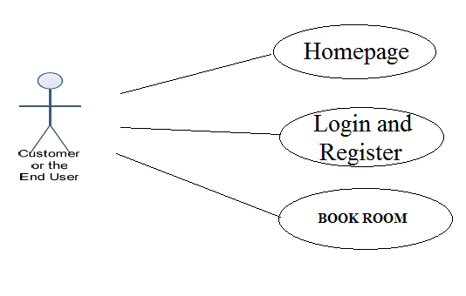
Figure 1 - Customer use case diagram

Some of the functions of the Hotel Management, such as creating, maintaining
and updating the database are available only to the administrator. The functions of the
administrator, explained in detail are as follows:

2.2.2 Administrator Activities
Login: The administrator has to login first in order to be able to make changes to the Hotel Management, by adding, deleting or modifying the data in the Hotel Management database.

Add/Modify Customer Information: Daily the Hotel Management will have many customers registering with the application and many of them unsubscribing. Only the administrator will have the sole rights to modify the database accordingly.

Add/Modify Flight Information: The Administrator also has the sole rights to add, delete or modify the HOTEL information. Sometimes any room information has to be modified or if any new flights need to be added to the database, these operations are performed by the administrator.

Figure 2 - administrator use case diagram

2.3 USER CHARACTERISTICS
There are two kinds of users for the Hotel Management. One is the customer and
the other is the administrator. The customers do not need to have any prior training to use the application. However, instructions for making room reservations would be provided to them through application. The administrators would however need to be trained in order to use the application.

2.4 CONSTRAINTS
In case of changes made to the database, the application should be able to show the
updated information without much delay. The database for the project is designed to be of moderate size. The Hotel Management system will be designed in such a way that, it can be run on a Windows 8 and its older versions. The .NET technology will be used to code the project and SQL server 2012 will act as the database for the project.

3. SPECIFIC REQUIREMENTS

3.1 EXTERNAL INTERFACES
The different types of interfaces that we would come across while developing the Hotel Management application are as follows:
• User Interface
• Hardware Interface
• Software Interface
3.1.1 USER INTERFACE
There are two types of users for the Hotel Management project. One is the
Customer and the other is the administrator. Both the customer and administrator user interface
would be a graphical user interface. The graphical user interface for the customer home page would be as follows:

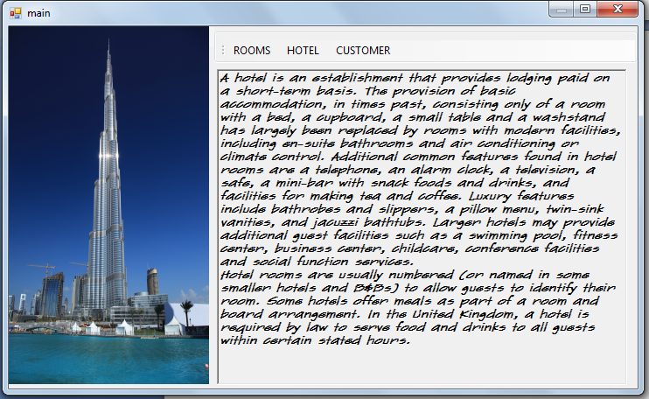

The Graphical User Interface would mainly consist of Hyperlinks push down buttons like the Login button etc.
The administrator of the website would also have a similar Graphical User Interface.
After an administrator logs onto the system, the home page for the administrator would be as follows:

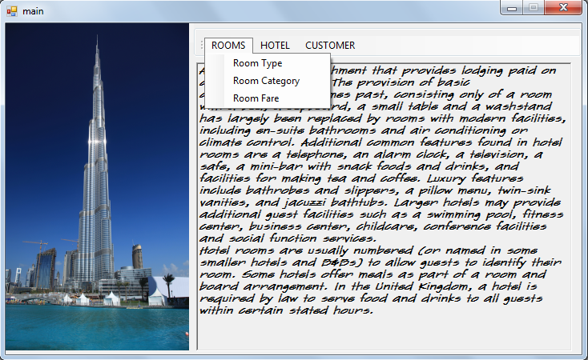

3.1.3 SOFTWARE INTERFACE
The application should run on a Windows 8 and its older versions Operating System. Since the application needs a database to store all the customer details, airline SQL server 2012 would be used.
Visual Studio.NET 2012 would be used for creating the application. All the coding will
be done in C#.

4. FUNCTIONAL REQUIREMENTS
The functional requirements of the Hotel Management are divided among the
Customer and the administrator of the application.
These functional requirements can be explained in detail as follows:

4.1 Use Case name: User Registration

• Description: This use case describes the scenario where the user registers with the
Application by providing all the necessary details, in order to make reservations or
bookings for rooms.
• Actor: User or the Customer
• Input: The user or the customer will have to provide all the necessary details present in
The customer registration form of the application.

4.2 Use Case name: User Login

• Description: This use case describes the scenario where the user logs into the
application, with the username and password
• Actor: User or the Customer
• Input: The user or the customer creates a username and password He then uses them to logon to the system and make reservations or views any information.

4.3 Use Case name: Book Flights

• Description: This use case describes the scenario where the user books hotel rooms.
• Actor: User or the Customer
• Input: After logging into the application, the customer looks up the information related
to various rooms and checks the availability of rooms. If he finds that there are
Any available rooms, he then books them.

4.4 Use Case name: Login/Logout

• Description: This use case describes the scenario where the administrator of the
application, logs into the system and logs out after the work is done.
• Actor: Administrator
• Input: The administrator logs into the application with the username and password provided to him.
• Output: The application verifies the authenticity and displays the home page of the
administrator.

4.5 Use Case name: Add/Delete or Modify Customer information

• Description: This use case describes the scenario where the administrator adds, deletes
or modifies customer information in the system database
• Actor: Administrator
• Input: The administrator of the applications logs onto the system with his username and password.
• Output: The application authenticates the administrator, and then displays the page
where the administrator can add new customers to the database, or delete existing
customers or modify details of customers in the database.

4.6 Use Case name: Add/Delete or Modify flight information

• Description: This use case describes the scenario where the administrator adds, deletes
or modifies rooms information in the application database
• Actor: Administrator
• Input: The administrator logs onto the system with the username and password provided to him.
• Output: The application authenticates the administrator, by verifying the username and
password. Then the application displays the page where the administrator can add new
rooms to the database.

5. PERFORMANCE REQUIREMENTS
The Hotel Management application should be able to respond to the queries
submitted by the customer without much delay. When a user searches for a room, the application should not take much time to return the results. Considering that the application is of moderate size, it should be able to display the results at a time on a page, when the customer looks up for any particular data.

CHAPTER 2 - ARCHITECTURE DESIGN

1. INTRODUCTION
The main purpose of the Architecture Design document is to discuss the architectural
design for the Hotel Management project in a clear and concise form. This design document will give a detailed description of the presentation tier, the middle tier which consists of the class diagrams, sequence diagrams for the Hotel Management and finally the data tier.

2. ARCHITECTURE OF THE AIRLINE RESERVATION SYSTEM

The architecture of the Hotel Management is based on the three-tier architecture.
This three-tier architecture mainly consists of three layers namely:
• Presentation Tier
• Business Tier
• Data Access Tier

The Presentation Tier converts and displays information into a human legible form. This
tier displays information related to services such as browsing the room avaliability, booking rooms etc. It communicates with the other tiers by outputting results to the client tier and all the other tiers. The Business Logic tier is mainly responsible for information exchange between the user interface and the database of the project. The final layer of the three tiered architecture is the Data Access tier, which mainly consists of the Database servers. The information related to the Hotel Management is stored and retrieved from here.
A simple representation of the three-tier architecture would be as follows:

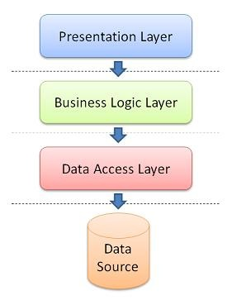

PRESENTATION TIER
The presentation tier is the top most layer of the Hotel Management application.
The presentation tier is mainly responsible for the user interface of the application which deals with the presentation of data to the user. The presentation tier of the Hotel Management is mainly formed by the C#.NET forms. In the case of the Hotel
Management project, I have used the Visual Studio 2012.NET to create the forms. Each form will have the extension .cs and there are several forms created for the user and the administrator.

BUSINESS LOGIC TIER
The Business Logic Tier is the middle tier of the three-tier architecture. The business
logic for the Hotel Management would be present here. In the case of my project, the C# classes would be performing the duty of the business logic. This is the layer which is responsible for the information exchange between the user interface and the database.
The Hotel Management mainly consists of the Users, which can be further
classified into the customer and administrator of the Hotel Management.
The class diagram for the Hotel Management would be as follows

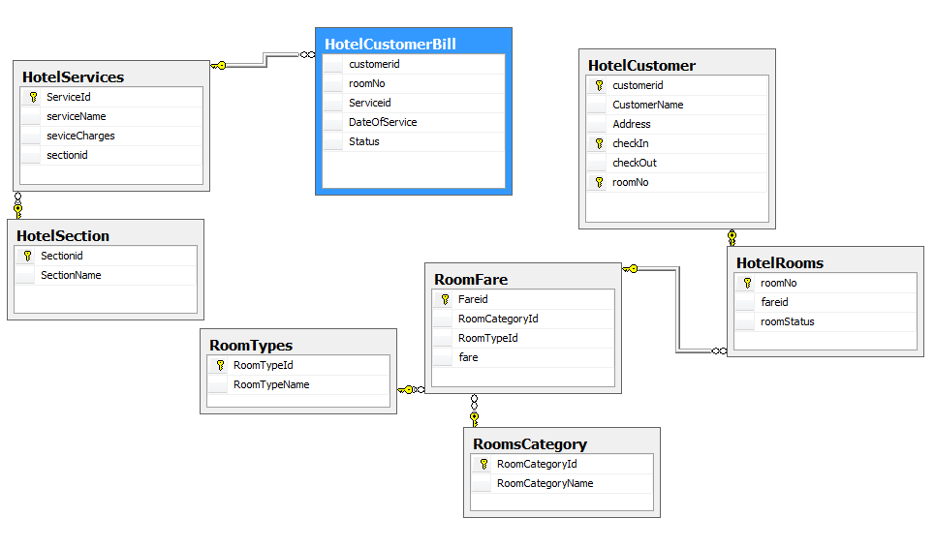

SEQUENCE DIAGRAM
The sequence diagram for the Customer of the Hotel Management would be as follows:

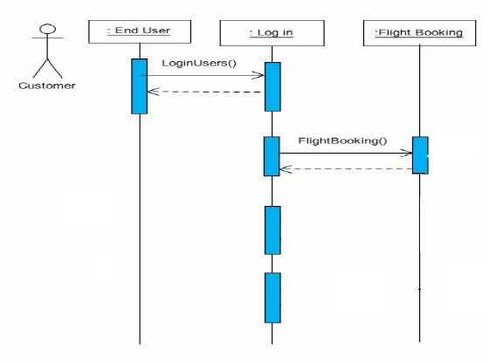
Room Booking
Room Booking

DATABASE TIER

The database tier is the final and last tier of the three-tier architecture. All the data related
to the Airline Reservation System project is stored and retrieved from here. For this project I have used the Microsoft SQL server to create the database. To be specific, Microsoft SQL server 2012 is being used. It is very easy to work with and makes creation and maintaining of tables very easy.

CHAPTER 3 - COMPONENT DESIGN

- INTRODUCTION AND PURPOSE

The main purpose of the Component Design document is to provide and explain the
component design for the Inventory Management System project in detail.

- CLASS DIAGRAM

The class diagram of the Inventory System project would be as follows:

2.1 CLASS DESCRIPTIONS

2.1.1 ROOM TYPES:-

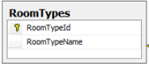
The attributes for the room types table are roomtypeid, which is a unique key and roomtypename.

2.1.2 ROOM CATEGORY:-

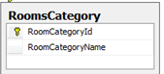
The attributes for the rooms category table are roomcategoryid, which is a unique key and roomcategoryname.

The functions of the above two table are that the admin can
Search for the type and category of the rooms.
Add the type or category of the room.

2.1.3 ROOM FARE:-

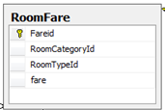

The attributes for the ROOMFARE table are fareid, which is a unique key, roomcategoryid, roomtypeid which are the foreign key and fare.

The function of this table is that the admin can enter the room fare corresponding to the room category and room type that are added in the hotel.

2.1.4 HOTEL SECTION:-

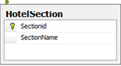

The attributes for the HotelSection are sectioned which is the primary key and Section name.

2.1.5 HOTEL SERVICES:-

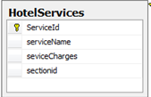

The attributes of this table are serviced which is a primary key, serviceName, serviceCharges and sectioned.

FUNCTIONS:-
The function of the above two tables are

Add:- admin can add the the Section and its corresponding services that are provided in the hotel to the customers.

2.1.6 HOTEL CUSTOMER:-

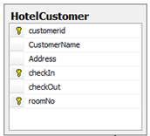

The attributes of this table are customerid, which is a primary key, customerName, Address, Checkin, Checkout and roomNo.

The functions of this form is :
The admin enters the customer details that are required by the hotel for the customer’s check in.
The admin asks the customer for his/her details and seeks for which type and category room he/she is availing for, then assigns the corresponding room.

2.1.7 CUSTOMER BILL:-

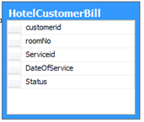

The attributes of this table are customerid which is a reference key, roomNO, serviced which is also a reference key, date of service and status.

The function of this table is;-
The admin retrieves the information about the customer’s stay in the hotel.
He adds the the room no in which the customer was staying.
Also he checks the service that a customer has prevailed during the stay
Finally he enters the status whether the bill has paid or it is pending.

CHAPTER 4 - TEST PLAN

- TEST PLAN IDENTIFIER

Hotel Management System

- INTRODUCTION

The main purpose of the test plan for the Hotel Management System is to discuss the
testing details of the use cases of the Hotel Management System. The software project test plan also describes the objective, scope and approach of the software testing effort for the Hotel Management System project. The test plan for the Hotel Management System also indicates the personnel responsible for each task and also specifies the risks associated with the test plan.

  - OBJECTIVES

The main objectives of the test plan for the Hotel Management System
are as follows:

• To identify the features of the system that will be tested.
• To identify and define all the activities necessary to prepare for and conduct the testing
process on the Hotel Management System.
• To discuss the testing techniques being used to test the Hotel Management System.

  - DEFINITIONS

The following are some of the terms and definitions that are related to the test plan of the
Hotel Management System:
• Pass/Fail criteria: Decision rules that are used to determine whether a software item
passes or fails a test.
• Test: A collection of one or more test cases
• Test Item: A software item that is an objective of testing.
• Test Plan: A document describing the scope, approach, resources and schedule of the
intended testing activities.
• Test Summary Report: A document summarizing the testing activities and results.
• Testing: The process of analyzing a software item to detect the differences between the
existing and required conditions.

- TEST ITEMS

This section of the test plan lists all the items of the Hotel Management System project that will be tested:
• Login
• generate bill
• Register
- APPROACH

This section of the test plan describes the overall approach for testing the Hotel Management System project. The approach followed for testing the Hotel Management System ensures that the major features of the project are adequately tested. The testing would be carried out on the Hotel Management System while logging into the system as a Hotel manager or a superadmin of the system.

  - UNIT TESTING

The Unit Testing is a test that tests each single module of the software to check for errors.
This is mainly done to discover errors in the code of the Hotel Management System. The main goal of the unit testing would be to isolate each part of the program and to check the correctness of the code. In the case of the Hotel Management System, all the forms and the C# classes will be tested. There are many benefits for this unit testing:
• The unit testing facilitates change in the code.
• It allows testing to be done in a bottom up fashion.
At the same time, unit testing has some disadvantages such as, it might not identify each
and every error in the system.

  - INTEGRATION TESTING

In Integration Testing, the individual software modules are combined and tested as a
whole unit. The integration testing generally follows unit testing where each module is tested as a separate unit. The main purpose of the integration testing is to test the functional and performance requirements on the major items of the project.
All the modules of the project developed individually would be combined together and
tested as a whole system in the integration testing.

  - REGRESSION TESTING

The Regression Testing is generally done whenever modifications are made to the source
code of a project. The Regression Testing can also be defined as the process of testing changes made to the computer program and also makes sure that the older programming still works with the new changes.
So, before any new version of a software product is released, the old test cases for the
project will be run against the software with the changes made, to make sure that the old
functionalities of the project still work.

  - ACCEPTANCE TESTING

This testing is generally performed when the project is nearing its end. This test mainly
qualifies the project and decides if it will be accepted by the users of the system. The users or the
customers of the project are responsible for the test.

  - SYSTEM TESTING

The system testing is mainly done on the whole integrated system to make sure that the
project that has been developed meets all the requirements. The test cases for the system testing will be the combination of unit and integration tests.

- TEST CASES

The following are the test cases for the Hotel Management System:

  - TEST CASE 1 – USER LOGIN

• Incorrect Input: Incorrect username.
• Pass Criteria: An appropriate message should be generated to indicate that an invalid
username has been typed.
• Correct Input: The correct input would be a valid username of the user and a correct
password associated with the username which he uses to log in.

  - TEST CASE 2 – USER REGISTRATION

• Incorrect Input: Wrong format entered in the input fields for the registration page.
• Pass Criteria: An appropriate message should be generated to the user saying that he has entered the wrong format in the specific input field.
• Correct Input: The correct input would a correct format entered by the user into the input fields of the registration page.
• Pass Criteria: The pass criteria for Hotel Management System.

  - TEST CASE 3 – USER REGISTRATION

• Incorrect Input: The data fields left out empty in the registration page.
• Pass Criteria: An error message should be generated to the user saying that he has to fill out those fields in order to be registered into the system.
• Correct Input: The correct input in this case, would be that the customer would enter the data in all the fields in the registration form.
• Pass Criteria: The pass criteria for the system would be that it accepts all the new user
details and then registers the user and helps him log into the system.

  - TEST CASE 4 – GENERATE BILL

• Incorrect Input: Incorrect input in this case, would be incorrect search criteria entered or incorrect format of data entered into the data entry fields of the generate bill page.
• Pass criteria: A message has to be generated to the user indicating the wrong entry that
he has made in the fields.
• Correct Input: A correct input would be entering the data into the data entry fields in a
correct format.
• Pass Criteria: The pass criteria for this test case would be that data will be added to the database.and bill will be generated

6. PASS OR FAIL CRITERIA
The test cases executed on the Hotel Management System will pass if they meet the
specific requirements mentioned in the Vision document of the project. A test case is said to fail, if the desired functionality is not satisfied by the system.

7. SUSPENSION CRITERIA AND RESUMPTION REQUIREMENTS

7.1 SUSPENSION CRITERIA

Testing for all the dependant features will be suspended if a test case fails. The failed test
case will be logged onto the test log which contains the description for the error.

7.2 RESUMPTION REQUIREMENT

The test cases which are not dependant on the case where the bug is reported will be
executed in parallel with the bug fixing. Once the failed test case has been taken note of and has been identified and fixed then the testing for the failed test case will resume.

8. TEST DELIVERABLES

The following documents will be produced after the testing phase for the Hotel Management System has been completed.
• Test Plan
• Test Cases
• Test Log

CHAPTER 5 - ASSESSMENT EVALUATION

- INTRODUCTION

The Assessment Evaluation document presents the results obtained by testing the Hotel Management System. The test cases are in reference to the test cases defined in the Test Plan document from the Phase II.

- TEST CASE RESULT SUMMARY

The summary of the test case result has been depicted in the table shown below:
These are the test cases for the User/Customer pages. The major part of testing has been
concentrated on the customer pages, as they would be the main clients of the Hotel Management System.

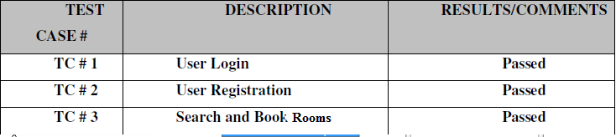

The below table represents the summary of results of testing on the Administrator pages.
The results have been explained in detail later in the document.

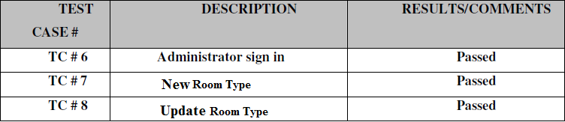

- DETAILED TEST RESULTS

  - MANUAL TESTING

To start with, I have performed manual testing on the Hotel Management System
Manual Testing is one of the oldest and rigorous methods of software testing. This
testing strategy gives the best opportunity to check every page thoroughly and make sure it works in the expected manner. Due to the complexity of the various automation tools and the time available for testing the entire application, I preferred to use manual testing based on the fact that it is one of the best methods of testing suggested for a beginner.
All the test cases mentioned in the Test Plan document of Phase II were tested here. The
results of the manual testing are represented in the following tables:

3.1.1 TC # 1 – USER LOGIN

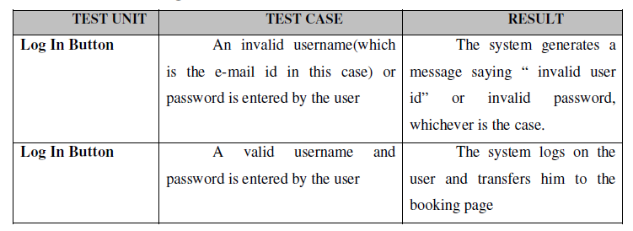

3.1.2 TC # 3 – SEARCH AND BOOK ROOMS

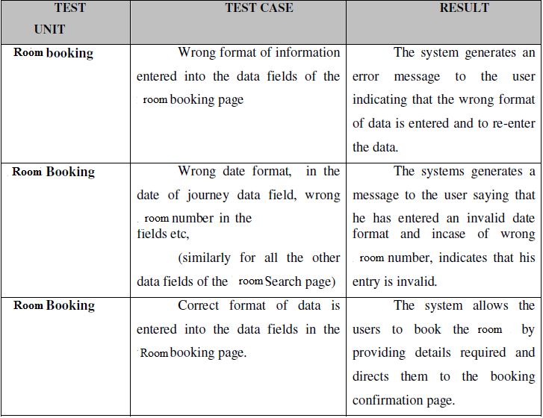

3.1.3 TC # 6 - ADMINISTRATOR SIGN IN

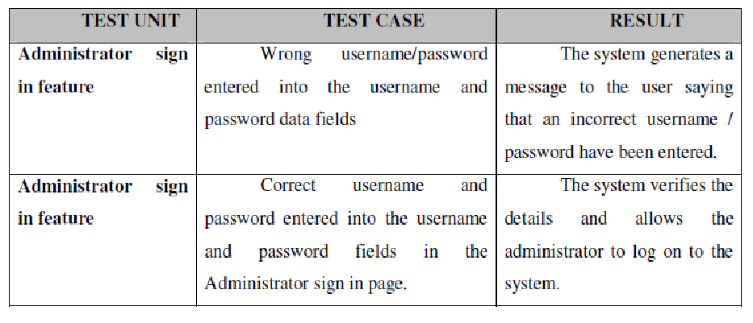

3.1.4 TC # 7 – NEW FLIGHT ADDITION

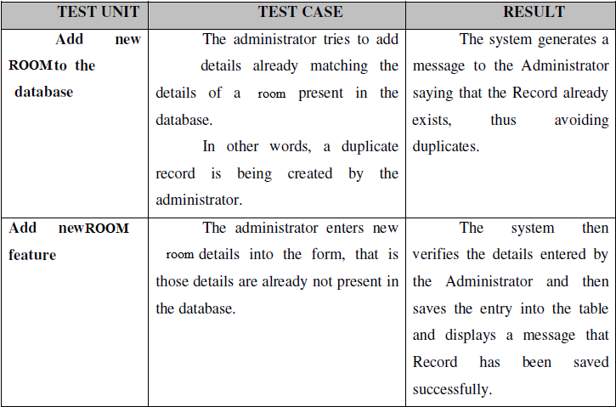

thus, the Administrator forms have also passed the manual testing phase and thus
the above results have been produced

CHAPTER 6 – SNAPSHOTS OF THE FORMS

- INTRODUCTION

The User Manual explains us the step by step procedure to use the Airline Reservation System application.

2 REQUIRED SOFTWARE

The required software for the Airline Reservation System project would be as follows:

• Operating System: Microsoft Windows 8 or lower .
• .NET Framework 4.0 SDK: It can be downloaded from Microsoft website (http://www.microsoft.com/en-in/download/details.aspx?id=3324).
• Microsoft Visual Studio .NET 2012: It can be downloaded from Microsoft website(http://www.microsoft.com/en-us/download/details.aspx?id=30678).
• Microsoft SQL server 2012: It can be downloaded from Microsoft website(http://www.microsoft.com/en-in/download/details.aspx?id=35575).

3 HOTEL MANAGEMENT SYSTEM DETAILED VIEW

- LOGIN FORM

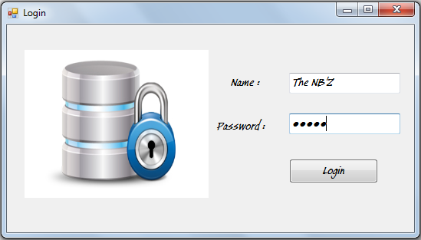

- MAIN FORM

The administrator can perform the following functions like
- Addition of new ROOM TYPES
- Add new ROOM CATEGORIES
- Add new Hotel section
- Add services
- Add Customers

- ROOM TYPE:-

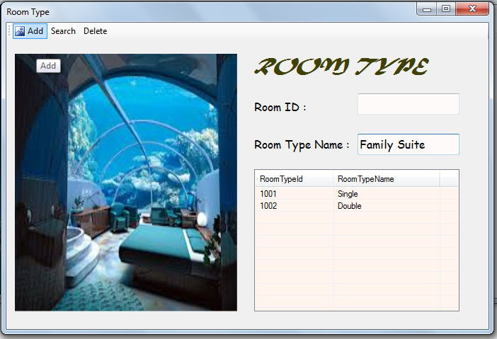

- ROOM CATEGORY:

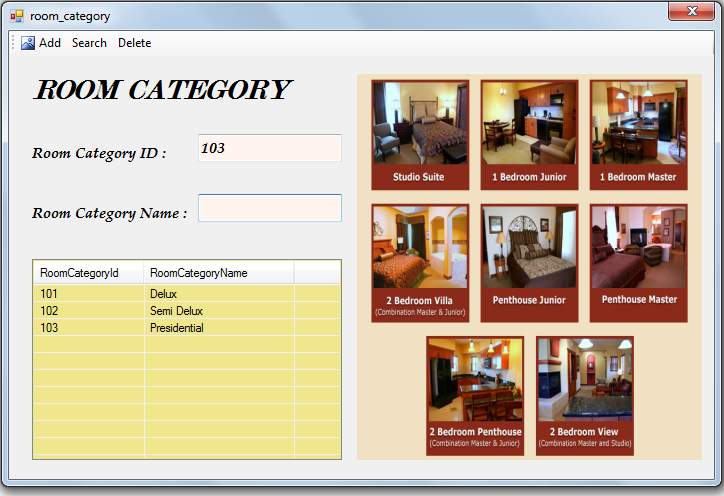

- ROOM FARE:-

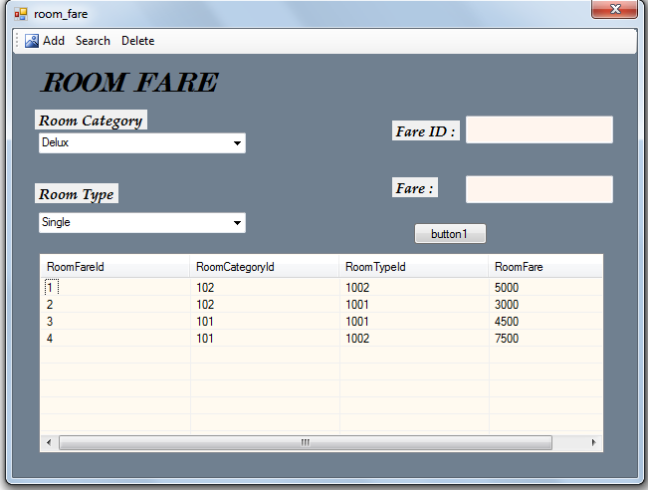

- HOTEL ROOM:-

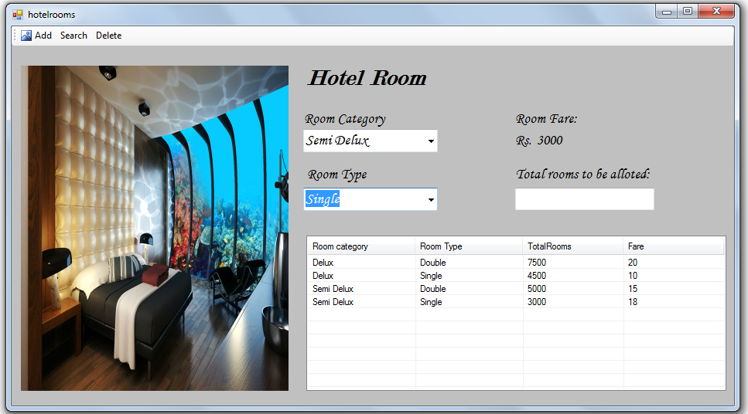
- HOTEL SECTION:-

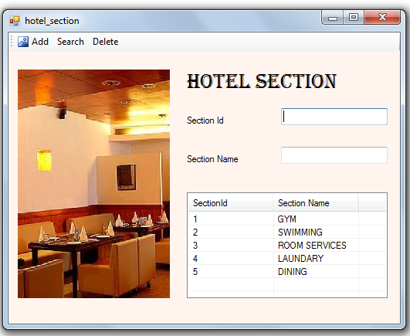

- HOTEL SERVICES:-

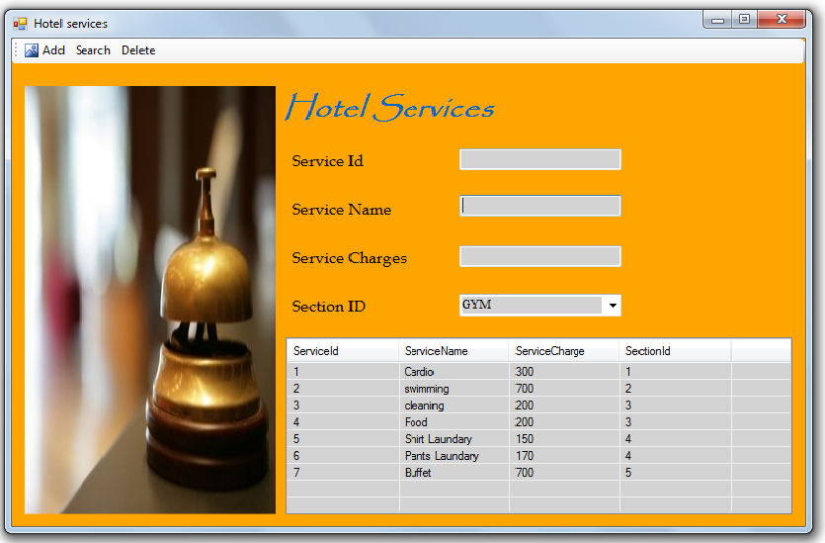

- CUSTOMER DETAILS:-

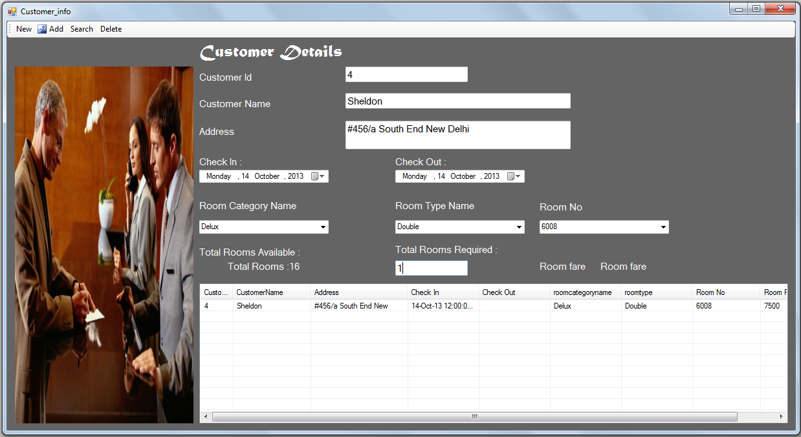

- SERVICE CHARGES:-

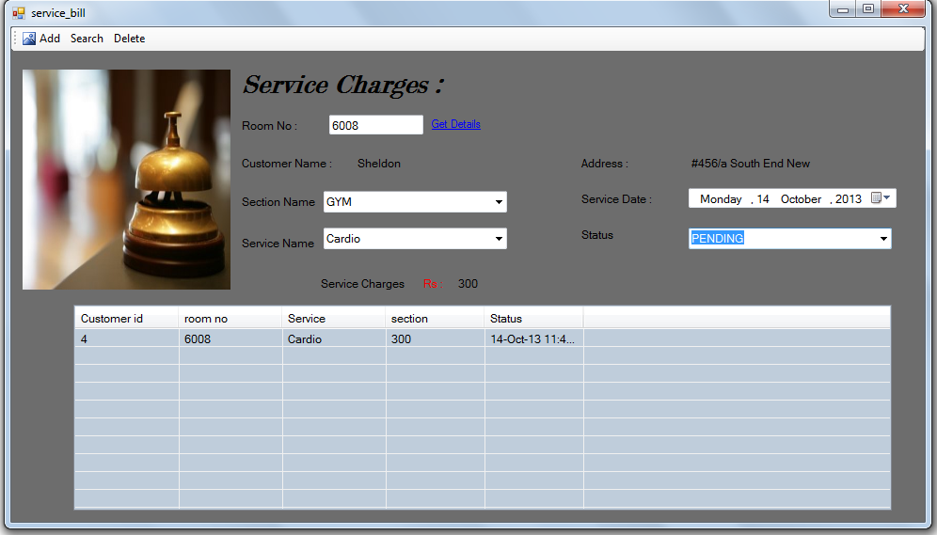

- CUSTOMER BILL:-

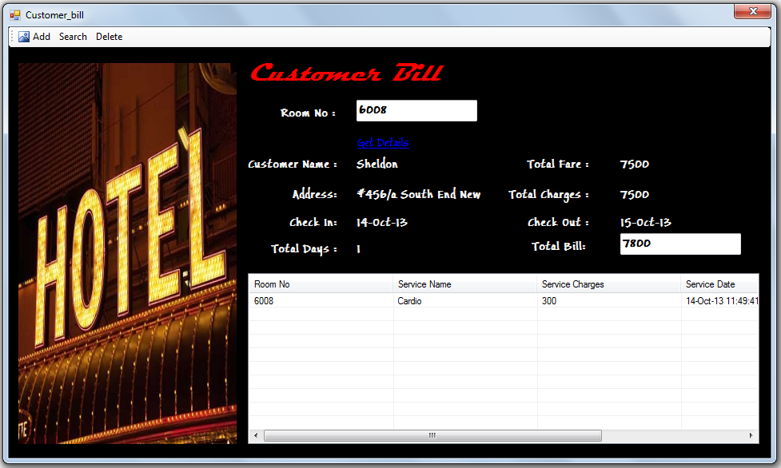

REFERENCES

The following references have been used by me, during all the phases of the MSE
project:

1. http://www.tutorialspoint.com/csharp/index.htm
2. http://msdn.microsoft.com/en-us/library/kx37x362(v=vs.80).aspx
3. SQL Server 2012 download - http://www.microsoft.com/en-in/download/details.aspx?id=35575
4. http://www.c-sharpcorner.com/
5. http://en.wikibooks.org/wiki/C_Sharp_Programming

